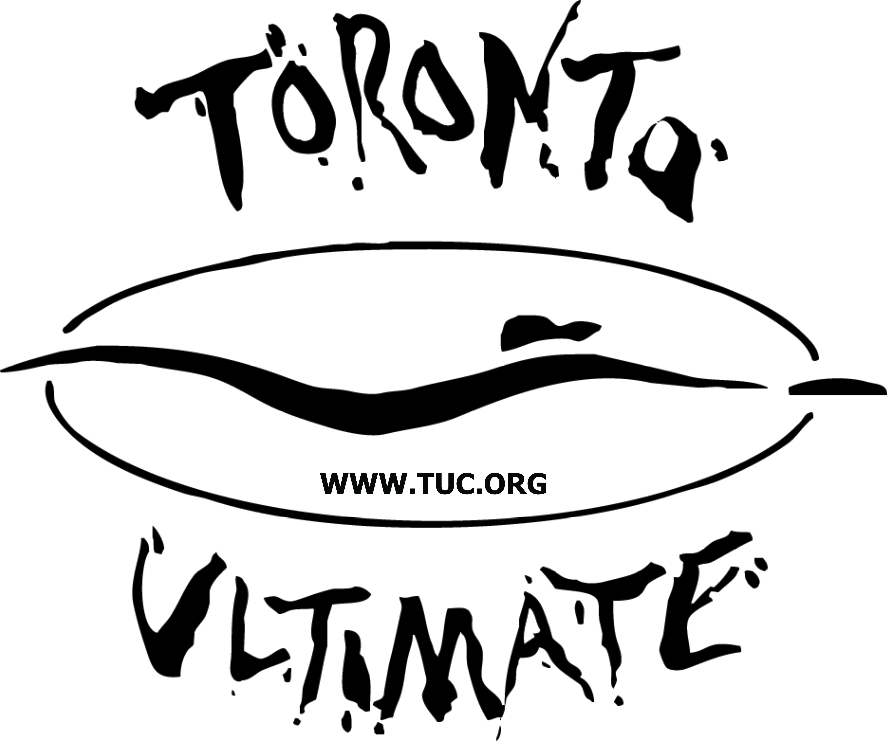
- TUC August Hat Tournament Information

- UPA 11th Edition rules (Speedpoint Rules)
    - Stall counts are 8 NOT 10
    - Halftime is mandatory to ensure teams switch ends of the field (1 horn)
    - Substitution on the fly: Every player entering the field must “high five” a player exiting the field
    - There is no pull after a point. When a team score, the offense can immediately start the other way
- There will be no foot blocks
- Gender format is 5:2 for this particular tournament.
- Games are 60 minutes in length (Halftime will sound at 30 minutes)
    - Two horns will signify last point of each game
    - One long horn will signify the start of each game
- Games are played to time: Hard time cap will begin 60 minutes after the schedule start time
    - Two horns will sound to signify the last point, finish the point that is currently in play. if the score is tied after the last point is played, one additional point (universe point) will be played to determine the winner
- Each team will get one time-out per game
- SPIRIT
    - Spirit MVP from each team will be awarded a prize at the conclusion of their team’s last game. The Spirit MVP will be selected by their teammates.
- Due to strict policies by Varsity Centre, there will be no pets allowed, no bicycles (must lock them outside the fence), no food, no beverage (except water), and no metal cleats (rubber cleats are allowed)
- TUC will provide water jugs along the sidelines and we encourage everyone to help themselves throughout the weekend
    - Be sure to bring water bottles and stay hydrated
- Please NO litter left behind
- Remember to bring extra cash as VC will be on-site and they usually do their best deals at tournaments
- TUC central will also be selling TUC 30th anniversary GALA tickets ($40)
- TIE BREAKERS are as follows:
    - A two team tie will be broken using the following criteria:
- If they played each other, head-to-head competition
- If they didn’t play each other, compare Point Differentials
- If still tied, Points Against will be compared
- If still tied, Points For will be compared
  - A three team tie will be broken using the following criteria:
- If they played each other, head-to-head competition
- If they didn’t play each other, compare Point Differentials
- If still tied, Points Against will be compared
- If still tied, Points For will be compared

